Missing values: 0

Summary statistics for target variables:

count 500.000000

mean 3410.006000

std 13095.803483

min 0.000000

25% 137.500000

50% 500.000000

75% 1700.000000

max 131000.000000

boxplot and histogram of target variable:  
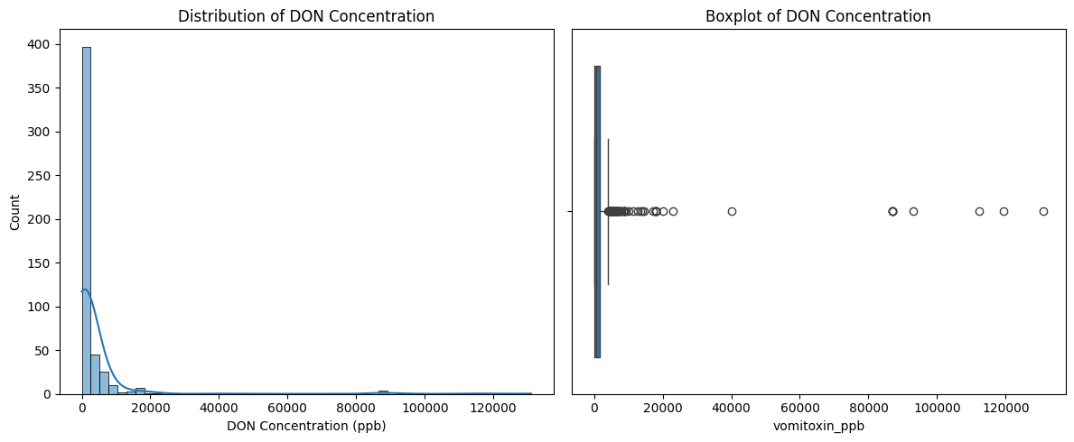

First ten samples:  
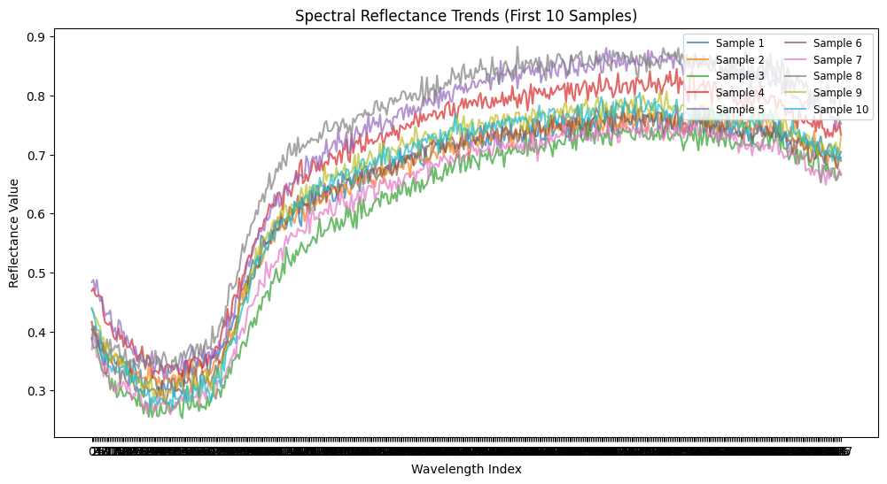

Average reflectance (8 outliers removed):  
  
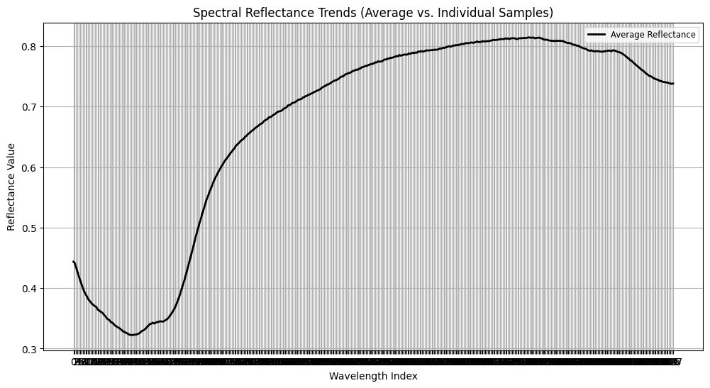

16 inconsistent samples removed:  
